**EXHIBITION AND SPONSORSHIP APPLICATION**

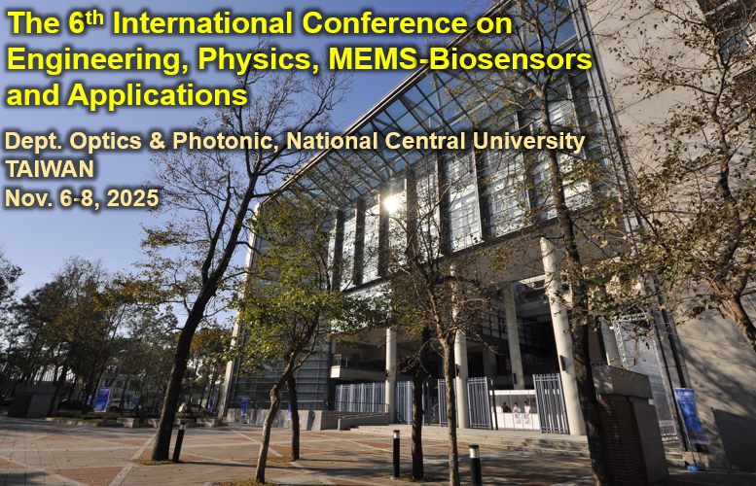

**Organizers**

This conference is organized by the Dept. of Optics & Photonics at National Central University.

**Exhibition Dates**

8:00 – 18:00 on November 7 (Friday), 2025.

**About ICEBA 2025**

The purpose of International Conference on Engineering, Physics, MEMS-Biosensors and Applications (ICEBA2025) is to link the researchers and scientists from Vietnam and other countries around the world, especially Asian countries, in the fields of biomedical engineering, health sciences, optics, and hi-tech sensors. In the event, we aim to promote international cooperation by joining research projects and international co-publications for the participants. ICEBA2025 will be host by the Department of Optics & Photonics of National Central University, Taiwan. We would like to express heartfelt gratitude to all the sponsors. Your dedication and support have been invaluable in making this event a reality.

**Exhibitions**

1. **Exhibition Site**

Dept. of Optics & Photonics, National Central University, Taiwan

1. **Exhibition Booth**

* Booth space: 3m (wide) × 2m (depth) × 2.5 m (high)
* One table (180 cm × 60 cm) and two chairs
* Electric power: 110V, 3 sockets
* Two registration badges, including the banquet per booth
* Advertisements: ICEBA2025 web page
* Fee:

|  |  |
| --- | --- |
| Booth Exhibition | Fee (Tax included) |
| Regular | NTD $20,000 |

Booth booking will be cancelled if the payment is not made by the due date (one week after receiving the notification email).

* Exhibitors will be notified about the date for the selection of booth locations.
* The organizer reserves the right to refuse any unsuitable booth booking.

**Sponsorship**

□ NTD $5,000. □ NTD $10,000. □ Other Amount:

Please contact the secretariat for other sponsorship options.

**Register Your Interest to Sponsor or Exhibit at ICEBA2025**

Please return the Exhibition and Sponsorship form before September 30, 2025 to [cckuo@ncu.edu.tw](mailto:cckuo@ncu.edu.tw) (Prof. Chien Cheng Kuo). A notification letter will be sent out once the request has been processed.

**Payment**

The exhibition/sponsorship fee is expected to pay in full within one week after receiving the notification email.

* *Pay in NTD*匯款戶名：台灣資訊儲存技術協會   
  銀行：兆豐國際商業銀行 (銀行代號：017) 分行：竹科新安分行(分行代碼0206)  
  帳號：020-09024329
* *Pay in USD*Remittance Account Name: TAIWAN INFORMATION STORAGE ASSOCIATION  
  Account Number: 020-09024329  
  Bank SWIFT/BIC number (for wire transfer): ICBCTWTP020  
  Bank Name: MEGA INTERNATIONAL COMMERCIAL BANK   
  Branch: HSINCHU SCIENCE PARK HSIN-AN  
  Address: No.1, Xin’an Rd., East Dist., Hsinchu City 300  
  Country: TAIWAN
* Please email the payment confirmation form (see below) to [cckuo@ncu.edu.tw](mailto:cckuo@ncu.edu.tw)within two days after the payment has been made. A confirmation email will be sent to the exhibitor/sponsor to confirm the completion of crediting the payment.

**ICEBA2025 Floorplans**

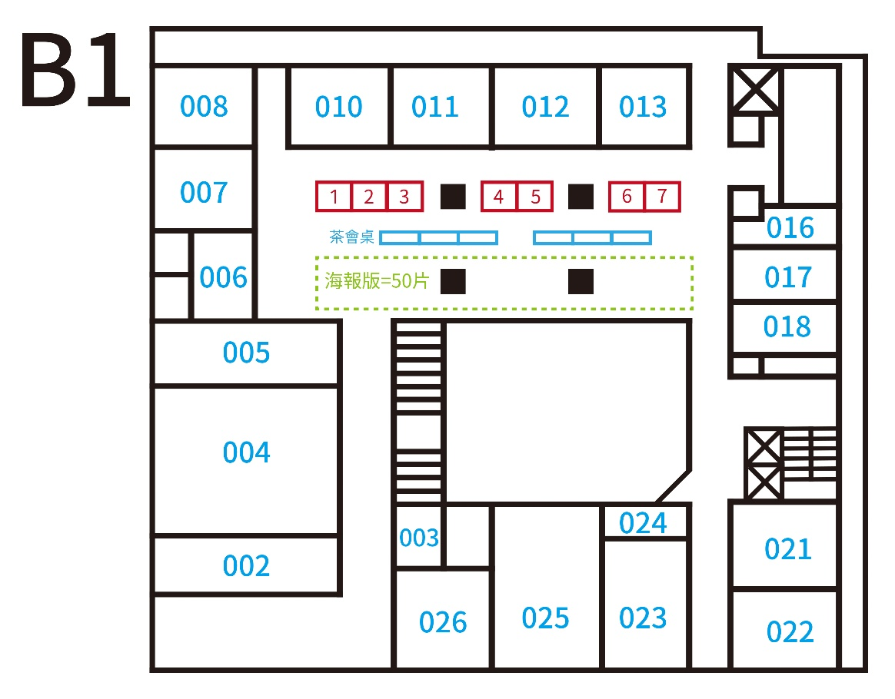

|  |  |  |  |  |  |  |
| --- | --- | --- | --- | --- | --- | --- |
| **ICEBA2025 Exhibition and Sponsorship Form** | | | | | | |
| No. | (by ICEBA2025) | Company name (English) | | |  | |
| Company name (Chinese) | | |  | |
| Tel |  | Company Homepage: | | |  | |
| Mailing address |  | | | | | |
| Event manager | Name | Dept./Title | Tel/Ext | Mobile | | E-mail |
|  |  |  |  | |  |
| Person of contact | Name | Dept./Title | Tel/Ext | Mobile | | E-mail |
|  |  |  |  | |  |
| Exhibition/Sponsorship | | | | | | |
| □ Booth Location (to be announced later): | | | | | | |
| □ Advertisement on ICEBA2025 Proceedings/Website | | | | | | |
| Total exhibition/Sponsorship fee: (written by ICEBA2025) | | | | | | |

Person of application (Signature): Date:

|  |  |  |  |
| --- | --- | --- | --- |
| **ICEBA2025 Exhibition/Sponsorship Payment Confirmation Form** | | | |
| Company Name |  | Title of Return Receipt |  |
| GUI number |  | Mailing Address |  |
| Contact Person of the Payment |  | Contact Person’s TEL |  |
| Name of the Remitter |  | Contact Person’s Email Address |  |
| Amount of Remittance |  | Time of Remittance |  |
| Paste the copy/image of the remittance slip or check here | | | |
|  | | | |

**Contact Us**

If you have any question, please feel free to contact us at

|  |  |  |  |
| --- | --- | --- | --- |
|  | **Person** | **TEL** | **E-mail** |
| NCU | Prof. Chien Cheng Kuo  (郭倩丞 教授) | +886905285658 | [cckuo@ncu.edu.tw](mailto:cckuo@ncu.edu.tw) |